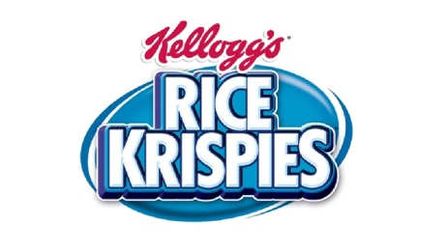

Kellogg’s Rice Krispies False Claims in 2010

In 2010 Kellogg’s Rice Krispies cereal was accused of misleading consumers. Their claims about immunity-boosting properties led to Kellogg’s paying $2.5 million to affected consumers. While there are certain unethical aspects to claims made by food organizations– and in this case Kellogg’s– it seems that this good has an element of credence. Claims that the cereal improved the immune health of children seems unprovable even after trial of the product. Despite this, it seems like *many* food companies make such claims. This advertising approach falls within the Targeting section of the Big Picture Framework. It’s particularly devious because it targets parents who have a concern for their children’s health. While Kellogg’s agreed to pay, they are still a financially vibrant company with more than $13 billion in annual revenue in 2020.

<https://www.youtube.com/watch?v=PvupQzSIGYc>